**CMPS405 Group Project**

**Phase 1 Report**

**GitHub Link:** <https://github.com/Arwa-Y/OS-Lab-Project>

QUID: 202009566 Student Name: Aisha Abdul Quadir

QUID: 202103676 Student Name: Mais Abushahla

QUID: 202102872 Student Name: Arwa Alsayed

Dr. Aws El-Din

Date: December 1, 2024

Section: B56

Fall 2024

|  |  |  |  |  |
| --- | --- | --- | --- | --- |
| Student | Tasks | | | Percentage |
| Server (VM1) | Client 1 (VM2) | Client 2 (VM3) |
| Mais |  | Checkmark outline |  | 33.33% |
| Aisha | Checkmark outline |  |  | 33.33% |
| Arwa |  |  | Checkmark outline | 33.33% |

**Screenshots Server:**

**Client 1 receiving system files:**

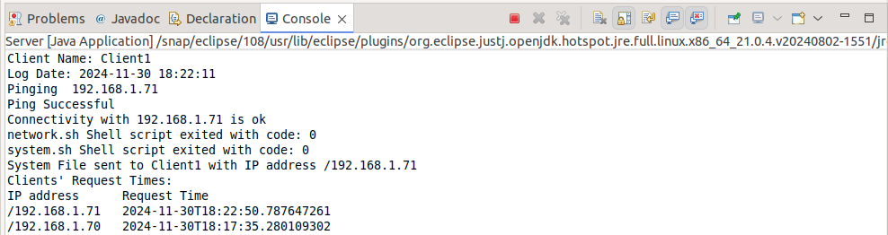

**Client 2 receiving system files**:

**Client 2 request denied**:

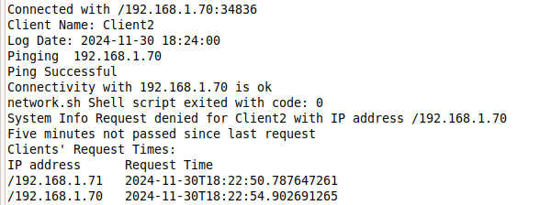

**Client 1 request denied**:

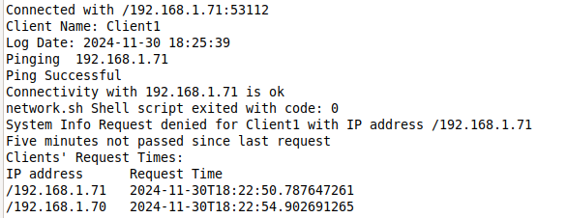

**Screenshots Client 1:**

**Check shell script running successfully.**

**Login script first attempt failed (password wrong), second attempt successful.**

**Logs out automatically after 30 seconds then ask if you want to request system information.**

**If system info request accepted:**

**System info file content:**

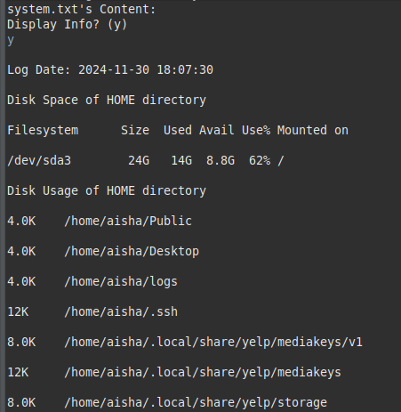

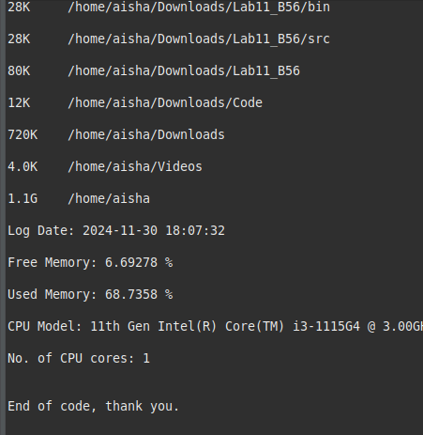

**Screenshots Client 2:**

**Search shell script running successfully.**

**Clientinfo script is successful, saves info to server every hour.**

**If system info request accepted.**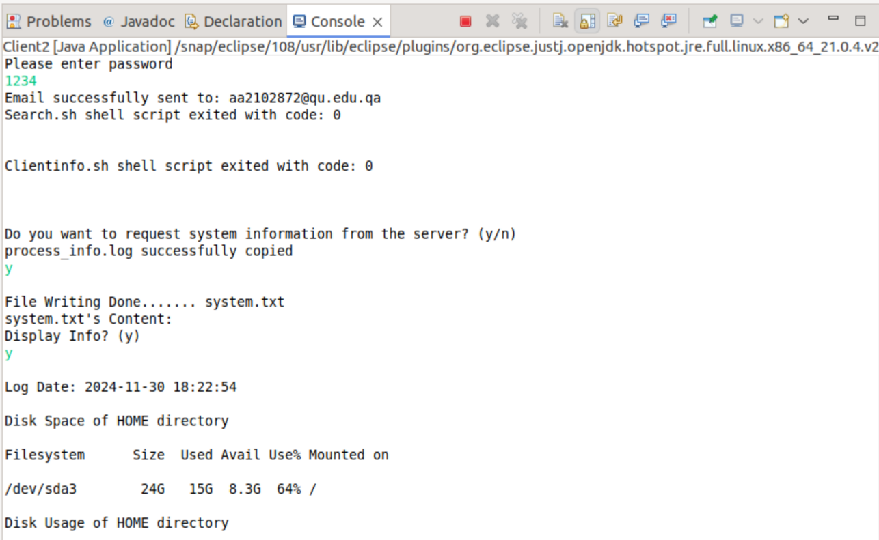

**If server denies request:**

